After action review

The key to implementing a successful AAR is by following these guidelines:

- All team members should be involved in the weekly review process. Team members get an opportunity to present their feedback and findings.
- An AAR should happen on a weekly basis. By getting into the habit of completing this exercise on a regular basis it will keep you focused on the end goal and prevent you from major deviations along the way. Reviewing the ups and the downs from the previous week allows you to adjust your plans before starting the new week.
- The review process is objective and focuses purely on the results. This process is not a blame game.
- Make this part of your culture. Make this review process a norm.
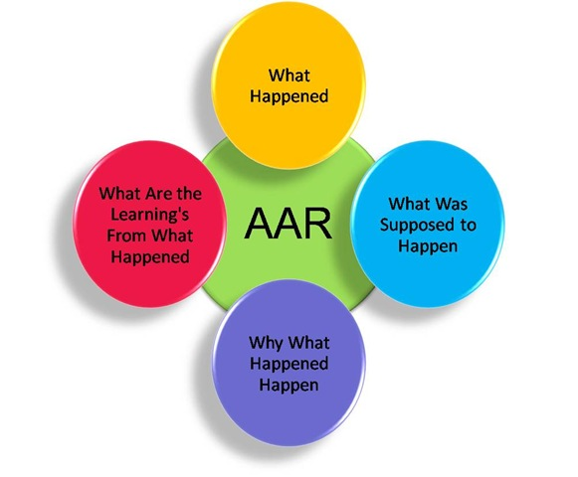

- What happened this week?
- What were the outcomes of the week? Do the outcomes align themselves to the original weekly plan or goals?
- Were there any GAPs?
- If there were GAPs, name them.
- Why did these GAPs happen?
- How can these GAPs be prevented into the future?
- Where were the weekly successes?
- What made them successful and how can these wins be repeated into the future?
- What is the new action plan going forward? (if any)

